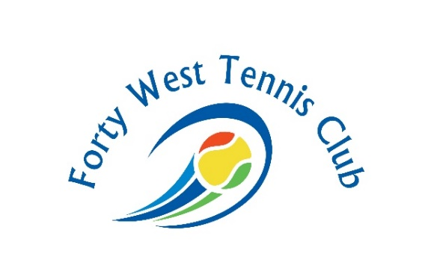
BLOCKTIME COURT REQUEST FORM 2020-2021

Court Captain________________________________________________________________
Email__________________________________________Phone No:____________________
My present block time is:______________________________________________________
If available, I would like to switch to this court time:________________________________
New Block time request: _______________________________________________________
Please return this form to Forty West Tennis Club by June 30, 2020.
Please note: The court captain is responsible for all payments and for making sure ALL players are current members of the club. Captains, please let Teresa know if you add any players to your block time during the year.
Full payment for the first half of block time will be due August 1, 2020. Full payment for the second half of block time will be due December 1, 2020.
List of players: NAME, EMAIL ADDRESS AND PHONE NUMBER (use back to add more players)
1.__________________________________________________________________________
2.__________________________________________________________________________
3.__________________________________________________________________________
4.__________________________________________________________________________
5.__________________________________________________________________________
6.__________________________________________________________________________
7.__________________________________________________________________________
8.__________________________________________________________________________
6421 Baltimore National Pike, Catonsville, MD 21228 410-747-5684

